Computer Language Coding Concepts

Event Situations
Several situations are possible in case of events. Events are multi-cast, meaning that multiple commands in multiple objects can run in response to the event. Also, a child object is not the only object you can pick up events from. You can also pick up events from deeper objects.

Multi-Cast Events
An event can be picked up by multiple parent objects when they both have a reference to the event-casting object and they both define an event command:

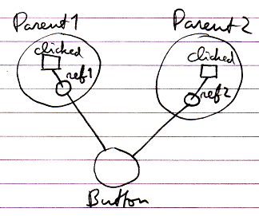

Multi-Cast in Same Parent
Multiple commands can be bound to an event, even when they both are defined inside the same parent object:

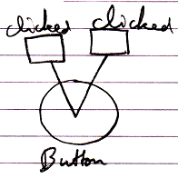

Event with Parameters
Events can have parameters. Here is an example of an event with a parameter.

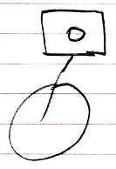

Event From Deeper Object
A child object is not the only object you can pick up events from. You can just as easily pick up events from a deeper object.

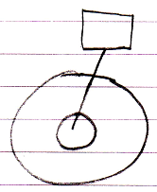

Author & Copyright: Jan-Joost van Zon Date: May 10, 2010 – May 14, 2010 Location: Oosterhout, The Netherlands Status: Finished

